**1. Create a Basic Tier Azure SQL Database**

* Follow the step-by-step process to create an Azure SQL Database using the Basic tier.

* Document the key configurations, including server name, authentication method, and storage settings.

* Take a screenshot of your successfully created database and attach it with your submission.

Server Name: nishatest.database.windows.net

Authentication Method: SQL Authentication

Storage settings: Basic

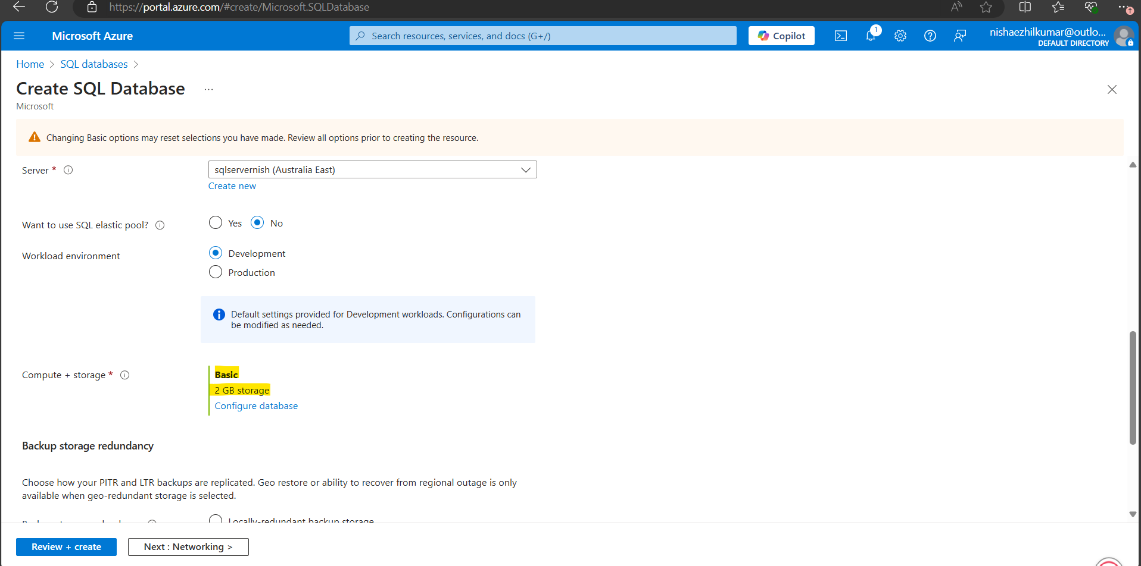

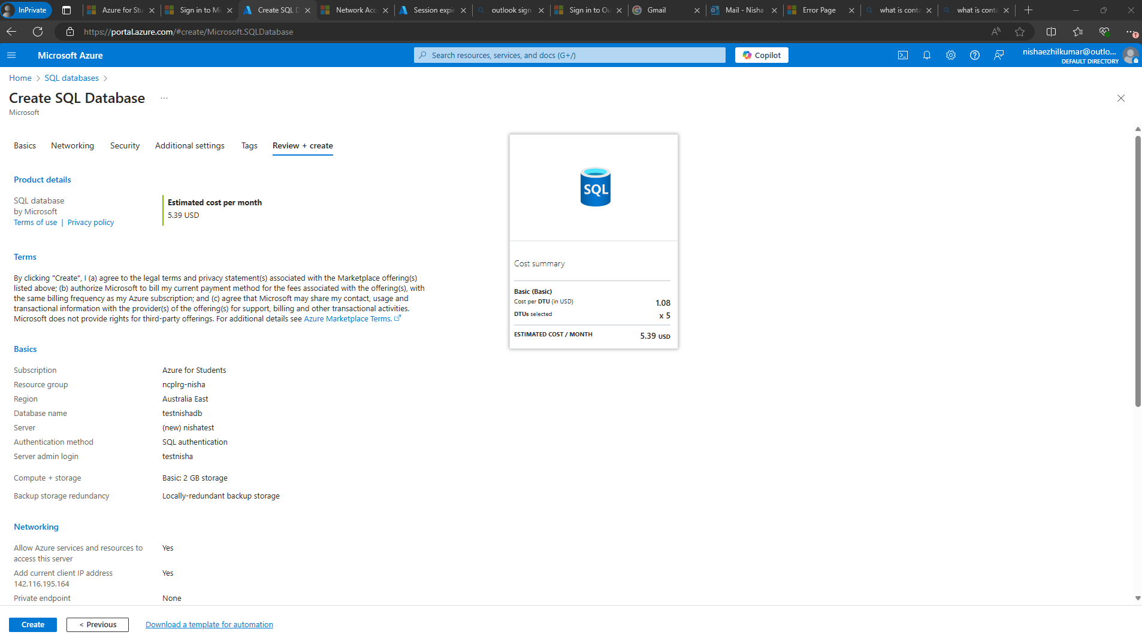

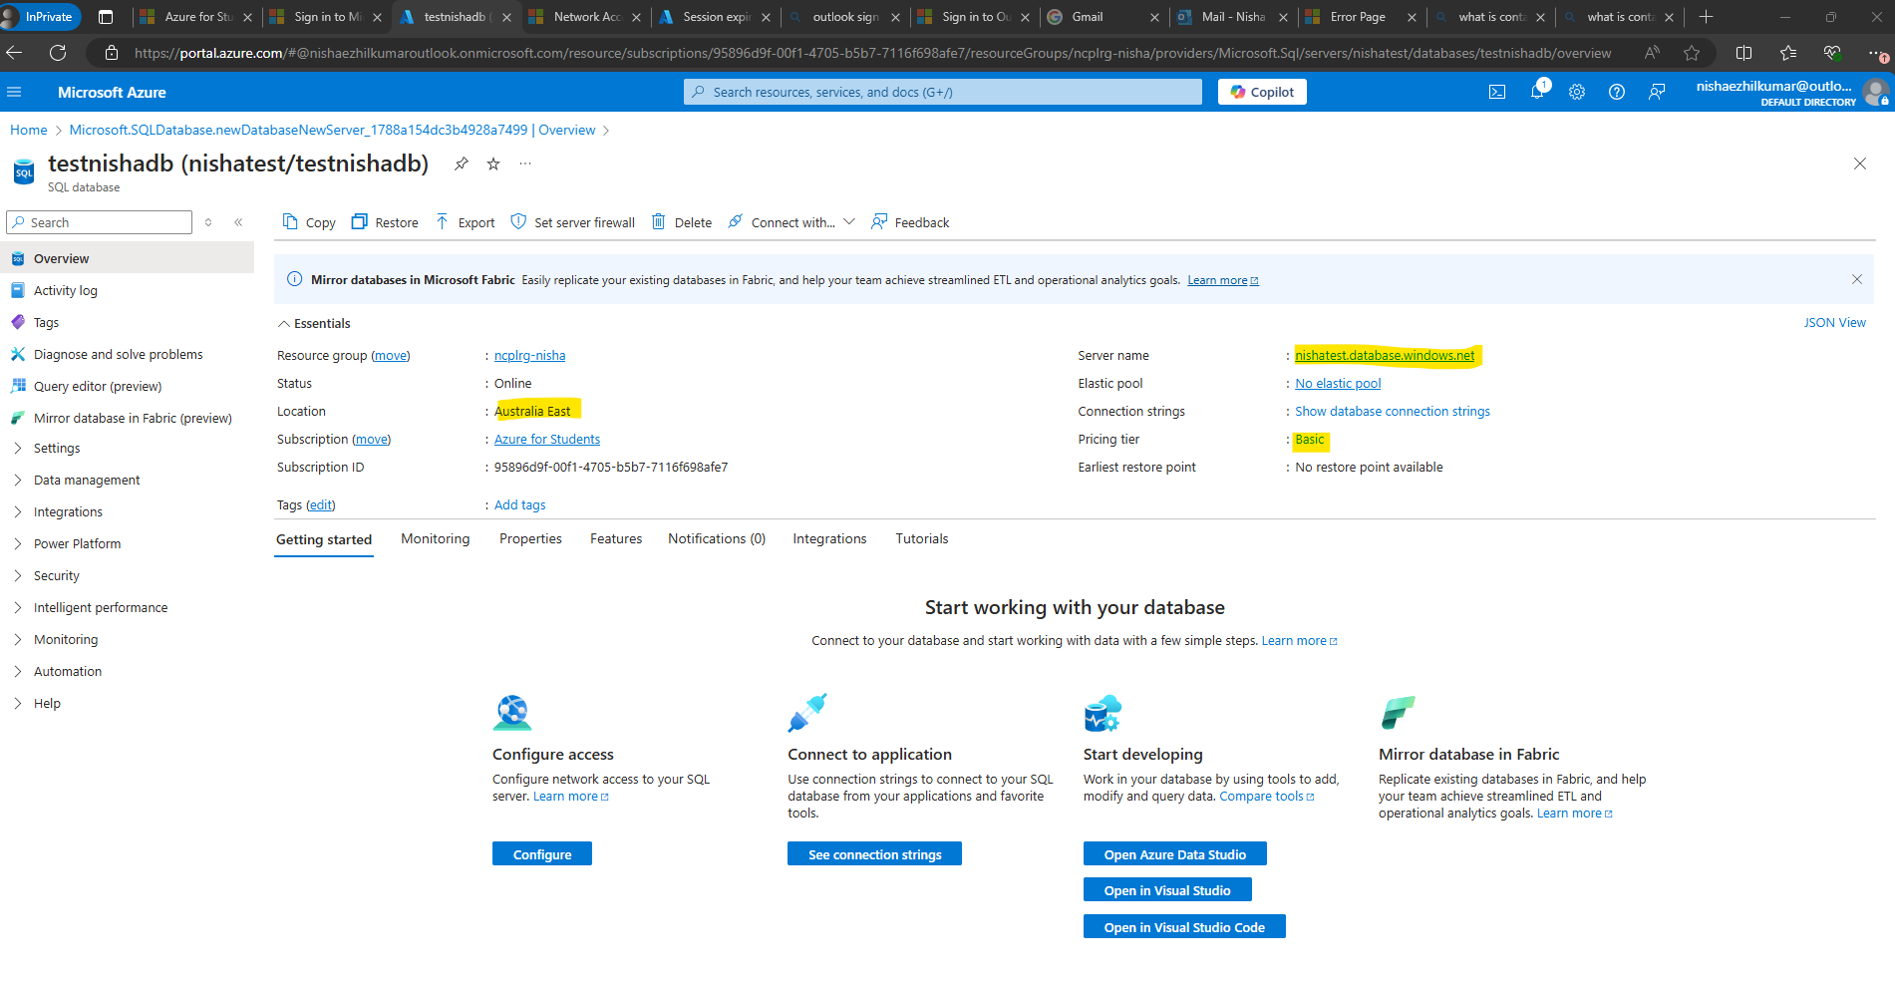

**2. Compare Authentication Methods**

* Research and document the difference between Microsoft Entra Authentication and SQL Authentication in Azure SQL Database.

**Microsoft Entra Authentication:**

1. **Identity Management**: Uses identities managed by Microsoft Entra ID (formerly Azure Active Directory) for authentication.
2. **Security**: Supports modern security features like multifactor authentication, conditional access policies, and centralized identity management.
3. **Integration**: Integrates with enterprise-level identity management systems, allowing for seamless single sign-on and centralized monitoring

**SQL Authentication:**

1. **Identity Management**: Uses traditional SQL Server logins and passwords for authentication.
2. **Security**: Relies on username and password credentials, which can be less secure compared to modern authentication methods.
3. **Integration**: Does not integrate with enterprise identity management systems, making it less suitable for environments requiring centralized access control.

* Provide at least three key differences and suggest a use case for each authentication method.

**Key Differences:**

1. **Authentication Method**: Microsoft Entra Authentication uses identities managed by Microsoft Entra ID, while SQL Authentication uses traditional SQL Server logins and passwords.
2. **Security Features**: Microsoft Entra Authentication supports multifactor authentication and conditional access policies, whereas SQL Authentication relies on username and password credentials.
3. **Integration**: Microsoft Entra Authentication integrates with enterprise identity management systems, while SQL Authentication does not

Use Cases:

1. Microsoft Entra Authentication: Ideal for organizations that require robust security measures and centralized identity management for their database access. Suitable for applications that need to comply with strict security and governance policies.
2. SQL Authentication: Suitable for legacy applications or scenarios where integration with enterprise identity management is not required. Can be used for simpler setups where SQL Server authentication is sufficient.

**3. Steps to Scale Up an Azure SQL Database**

* Write down the steps to scale up your Azure SQL Database to a higher performance tier.

**Sign in to the Azure Portal**: Go to the Azure Portal and sign in with your account.

**Navigate to your SQL Database**: In the Azure Portal, search for and select "SQL databases" under the "SQL" section.

**Select your Database**: Choose the SQL Database you want to scale up from the list of databases.

**Choose the New Tier**: Select the desired performance tier (e.g., General Purpose, Business Critical, or Hyperscale) and the appropriate service tier. You can also adjust the number of vCores, memory, and storage based on your needs1.

**Review and Apply**: Review the changes and click "Apply" to scale up your database

* Mention the potential impact on performance and cost considerations when scaling up.

**Performance Impact:**

1. **Better Performance**: Scaling up means more power and speed for your database, so it can handle more data and users efficiently.
2. **Higher Reliability**: Better performance tiers often have more features to ensure your data is always available and safe.
3. **Greater Capacity**: More resources mean your database can store more data and handle more complex queries.

**Cost Considerations:**

1. **Higher Costs**: Moving to a better performance tier means paying more for the extra resources.
2. **Balance Needs and Budget**: Make sure you choose a tier that gives you the performance you need without overspending.
3. **Cost vs. Benefit**: Think about whether the improved performance is worth the extra cost for your specific needs.

**When to Scale Up:**

* **Need More Power**: When your current setup is too slow or can’t handle the workload.
* **Increased Demand**: When you expect more users or more data.
* **Improving Reliability**: When you need to ensure your data is always available and secure.